**West Coast Collaborative**

**Specialist Mathematics Units 3 & 4**

**Investigation 1, 2018**

**Name: ____________________________**

In Class Task: Wheel of Steel Total Marks 35

Time 55 minutes.

You may have your take home component and Classpad calculator.

The motion of the mini wheels are now to be considered.

The mini wheels rotate once every 20 seconds.

The radius of the mini wheel is 1.5 m. The wheel rotates in a

clockwise direction. Initially *V* is vertically below *A.*

*V*

A

***j***

***i***

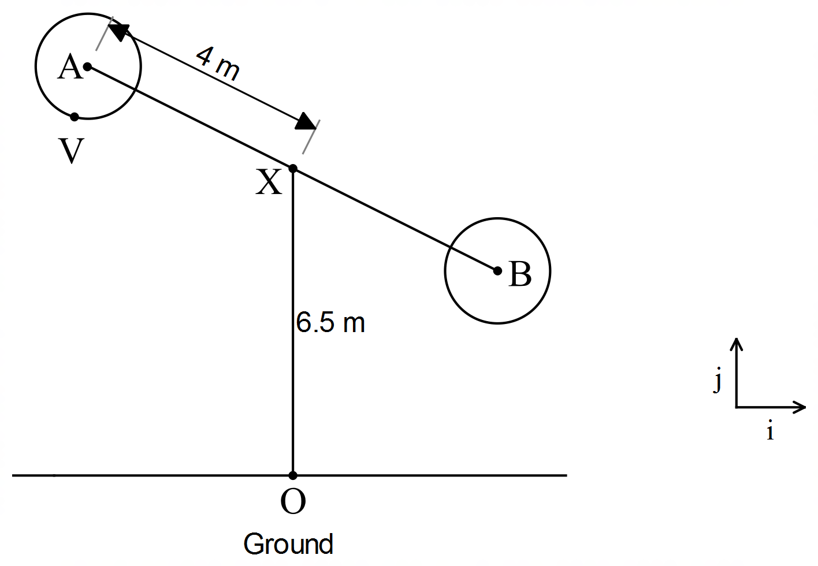

1. State the vector equation describing the motion of *V*, relative to *A* as a function of *t* (*t* is measured in minutes).That is state the vector equation of 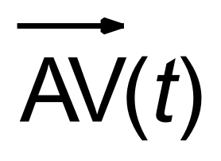 **. (5 marks)**
2. Determine the position vector of *V* relative to *O* at time *t,* that is 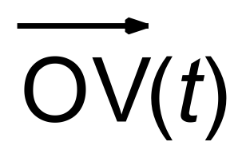 , where the initial position of *V* is vertically below A and the initial conditions for *A* are as described in the Take Home Section of the investigation, that is  *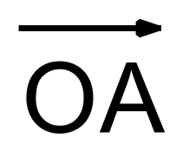(t*) = 4 sin (2π t) ***i*** + (–4cos (2π t) + 6.5) ***j*** **(2 marks)**

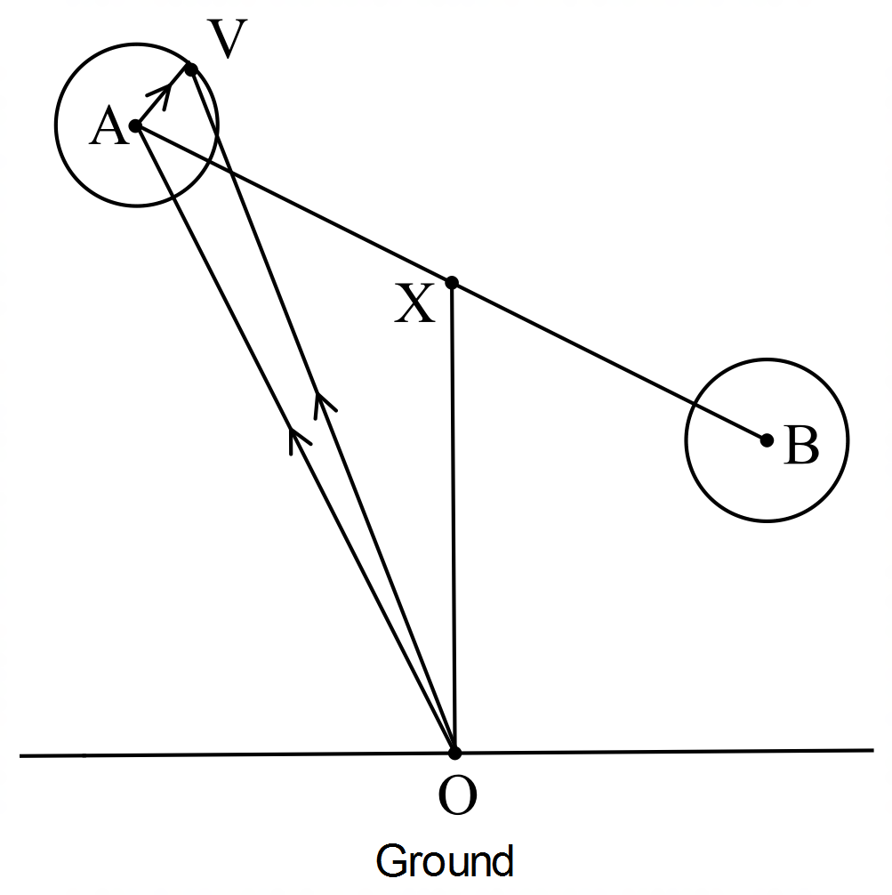

1. Plot the graph of the path of V and show the direction it is travelling in. **(6 marks)**

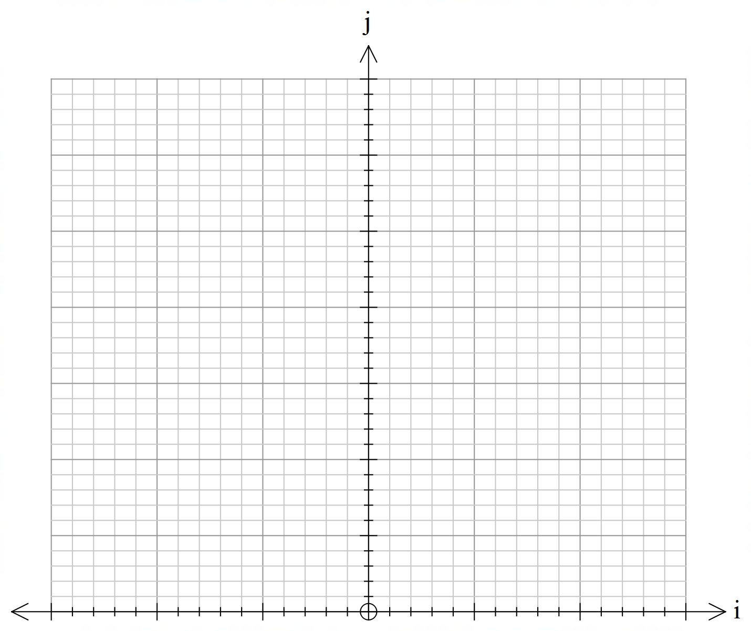

1. Find the velocity of point *V* as a vector function of *t*. **(4 marks)**
2. Find the speed of point *V* at time *t* and hence find the maximum and minimum speeds of point *V* and the times at which these occur in the first revolution of rod *AB* (exact values required). **(8 marks)**
3. Describe the position of point *V* at these times of maximum and minimum speeds. (Hint: it may help to consider a diagram of the Wheel of Steel) **(5 marks)**
4. Plot the graph of speed against time for 0 ≤ *t* ≤ 1. **(5 marks)**

